**Jeyasingh, Shobana (b. 26 March 1957, Chennai, India – )**

**Summary**

Shobana Jeyasingh is a British choreographer whose work deploys both modern and postmodern aesthetics. Drawing on the bharata natyam form in which she trained, Jeyasingh deconstructs the classical vocabulary through a process she describes as ‘asking questions of the adavus [units of movement].’[1] Jeyasingh’s choreography also incorporates pedestrian movement, postmodern dance, ballet, and martial arts such as kalaripayattu. She works within a high modernist tradition that privileges choreographic form over dramatic expression, highlighting non-representational movement, fragmentation, and the arrangement of dancers in complex groupings; she also, especially in more recent work, engages with postmodern, thematic concerns such as taking the surface seriously, exploring personal narratives, and reflecting on the complexity of belonging. An articulate critic as well as a choreographer, Jeyasingh has created a series of commentaries in which she reflects on postcoloniality, globalization, and urbanization as they play out in her work. She was also one of the first authors to discuss the contingent and constructed nature of the bharata natyam tradition. As one of the leaders in the field of contemporary South Asian dance, Jeyasingh created a space in the contemporary British dance milieu for choreographers working with classical non-Western vocabularies. She led the way for a generation of choreographers to challenge the racialized underpinnings of British contemporary dance as well as to query the imperative that South Asian classical forms demonstrate historical continuity, thereby contributing to the vibrant field of South Asian dance in Britain and extending understandings of experimentation in British contemporary dance.

**Training**

Born in Madras (now Chennai), South India, Shobana Jeyasingh began her dance career by training in bharata natyam. As a child and young adult, she also lived in Sri Lanka and Singapore, ushering in a global awareness early on in her life and urging her to question fixed notions of belonging. At age eighteen, she moved to the UK to pursue a degree in Shakespearian studies. There, she continued her performance work but quickly became disillusioned with the state of South Asian dance in Britain, particularly the assumption on the part of the British public that South Asian dancers must be cultural ambassadors. She found particularly problematic the British assumption that forms like bharata natyam are more about literal meaning than about formal elements such as shape, space, and time. In her early writing and choreography alike, she rejected the demand for dramatic meaning and instead focused on the choreographic components of classical bharata natyam, such as linearity, angularity, a grounded use of weight, and an internal geometry. She founded Shobana Jeyasingh Dance in 1988 as a means of exploring and challenging such choreographic conventions with a company of dancers.

**Contributions to Modernism**

Like many modern choreographers, Jeyasingh began her exploration of new material by rejecting existing conventions and expectations. Thus, she moved away from literal, dramatic meaning and music as governing choreography. Her dancers do not directly invoke emotional states nor do they depict characters. Although Jeyasingh sometimes works closely with composers, frequently her choreography creates a tension with the music, rather than following it or creating a framework to which the music then adheres. Throughout her choreographic career, she has focused on fragmenting the choreographic layering of solo bharata natyam, distributing its elements across a company of dancers. In early works such as *Making of Maps* (1992), her interest in delayering and fragmentation enable her introduction of a degree of spatial complexity not present in the classical form as she created dancers’ pathways that intersect, collide, and cross the stage in diagonals and circular patterns. In *Romance… with Footnotes* (1993), she also encourages her dancers off the vertical meridian into partnered work with one another and into floor work. This piece also retains bharata natyam’s contrast between lyrical and dynamic choreography but amplifies this tension as dancers often spiral out into explosive, frenetic phrases that contrast with methodical dreamlike sections.

In more recent work, Jeyasingh has re-considered the question of dramatic meaning, deploying fragmented narratives, the play of images across dancing bodies, and characterizations that shift across a company of dancers. Perhaps because of Jeyasingh’s success with her early works, because of the presence of organizations such as Akademi, a South Asian dance interest group, in the British dance sector, and because of the success of postmodern choreographer Akram Khan, UK viewers no longer so readily associate South Asian dance solely with narrative and expressivity. Options for reconsidering the relationship between choreography and emotion are now more open than they once were. Pieces such as *Exit No Exit* (2006) and *Faultline* (2007) reincorporate expressivity into choreography, exploring shifting relationships between individuals and groups.

Like a number of South Asian and South Asian diaspora modernists, Jeyasingh recognizes the unstable and contingent nature of the Indian classical forms. Whereas other choreographers, such as Chandralekha and Astad Deboo, seek an indigenous Indian modernism, Jeyasingh considers herself foremost a British choreographer and makes overt her investigation of both British and Indian modernist and postmodern aesthetics. Her later work hinges upon choreographic strategies such as fragmentation, interruption, the explicit quotation of classical forms, and an investigation into the elusive nature of history and identity.

**Legacy**

Together with organisations such as Akademi and Sampad, Jeyasingh helped create the field of South Asian dance in Britain, now a vital arena of choreographic exploration. Important emerging choreographers—such as Natasha Bakht, Mavin Khoo, and Jiva Parthipan—danced in her company. Similarly, postmodern British Asian choreographers like Akram Khan owe much to Jeyasingh’s groundbreaking experiments. Her company has changed the British contemporary dance milieu, challenging associations of modernism with whiteness/Britishness, and reminding a British dance public that modern aesthetics run throughout a number of forms, including postcolonial ones.

Jeyasingh’s company has toured primarily in Britain, although the company toured India for the first time in 2010. Jeyasingh, however, is resistant to the idea that her work is Indian and thus should automatically be of interest in India. She also has received international commissions from arts organizations in Venice, Toronto, Hong Kong, and Beijing. She sees her choreography as British and, yet, as resolutely global. In this way, her work participates in the globalization of contemporary dance in the late twentieth and early twenty-first centuries.

**Janet O’Shea**

**Selected Works:**

*Configurations* (1988)

*Correspondences*  (1990)

*Byzantium* (1991)

*Making of Maps* (1992)

*Romance… with Footnotes* (1993)

*Raid* (1995)

*Palimpsest* (1996)

*Fine Frenzy* (1999)

*Surface Tension* (2000)

*Phantasmaton* (2002)

*Foliage Chorus* (2004)

*Flicker* (2005)

*Exit No Exit* (2006)

*Faultline* (2007)

*Just Add Water?* (2009)

*Bruise Blood* (2009)

*Counterpoint* (2010)

*TooMortal* (2012)

*Strange Blooms* (2013)

*Bayadere – Ninth Life* (2015)

**Artist’s Writings**

Jeyasingh, S. (1990) ‘Getting Off the Orient Express,’ *Dance Theatre Journal* 8, 2: 34-37. Rprt (2010) in *The Routledge Dance Studies Reader*, 2nd ed., eds. A. Carter and J. O’Shea, Oxon and New York: Routledge, 181-87.

---------- (1992), ‘What is Dance?’ *Dance Now*, Spring, 21-22

---------- (1995), ‘Imaginary Homelands: Creating a New Dance Language,’ in *Border Tensions: Dance Discourse*, Guildford: University of Surrey, 191-97. Rprt (1998) in *The Routledge Dance Studies Reader,* ed. A. Carter, London and New York: Routledge, 46-52.

---------- (1997) ‘Text context dance,’ in *Choreography and Dance: South Asian Dance*, ed. A. Iyer, Amsterdam: Harwood Academic Publishing, 4 (2), 31-34.

**References and further reading**:

Briginshaw, V. (2001) ‘’Hybridity and nomadic subjectivity in Shobana Jeyasingh’s *Duets with Automobiles*,’ in *Dance, Space and Subjectivity*, London: Palgrave, 97-111.

Jordan, S. (1996) ‘Networking Dances: Home and Away in the Choreography of Shobana Jeyasingh,’ in *New Dances from Old Cultures: Green Mill Papers 1996*, eds. C. Hill and U., Braddon: The Australian Dance Council.

Katrak, K.H. (2011) *Contemporary Indian Dance: New Creative Choreography in India and the Diaspora*, New York: Palgrave Macmillan.

O’Shea, J. ( 2007) *At Home in the World: Bharata Natyam on the Global Stage*. Middletown: Wesleyan University Press.

--------- (2008) ‘Unbalancing the Authentic/Partnering Classicism: Shobana Jeyasingh’s Choreography and the Bharata Natyam “Tradition”,’ in *Decentring Dancing Texts: The Challenge of Interpreting Dances*, ed. J. Lansdale, Basingstoke: Palgrave Macmillan.

Prickett, S. (2013) ‘Encountering the South Asian Diaspora: Dance Education, Heritage and Public Performance in London,’ in *Embodied Politics: Dance, Protest* *and* *Identities*, Binsted: Dance Books, 134-77.

Roy, S. (1997) ‘Dirt, Noise, Traffic: Contemporary Indian Dance in the Western City: Modernity, Ethnicity, and Hybridity,’ in *Dance and the City*, ed. H. Thomas, New York: St. Martin’s Press, 68-85.

**Digital Documentation**

Roy, S. (2009) ‘Step-by-Step Guide to Dance: Shobana Jeyasingh,’ *The Guardian*, 21 October. <http://www.guardian.co.uk/stage/2009/oct/20/shobana-jeyasingh>.

**Film Documentation**Jeyasingh, S. (1993) *Duets with Automobiles,* London: Illuminations Media.

<http://www.shobanajeyasingh.co.uk/works/duets-with-automobiles/>

---------- (2000) *Surface Tension*, London: Shobana Jeyasingh Dance Company.

<http://www.shobanajeyasingh.co.uk/wp-content/uploads/Faultline-and-ST_DVD_order2012.pdf>

----------- (2004) *Animating Architecture: Foliage Chorus*, London: ResCen Publications

<http://www.rescen.net/Shobana_Jeyasingh/foliage.html#.Vdt3krxViko>

----------- (2007) *Faultline,* London: Shobana Jeyasingh Dance Company.

<http://www.shobanajeyasingh.co.uk/works/faultline/>

**Paratextual Materials**

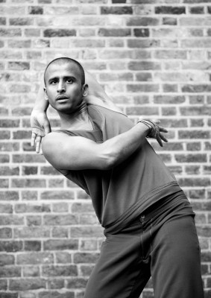

Bruise Blood, 2010. Photo: Nuno Santos. Dancers: Devaraj Thimmaiah

<http://www.shobanajeyasingh.co.uk/gallery/images/>

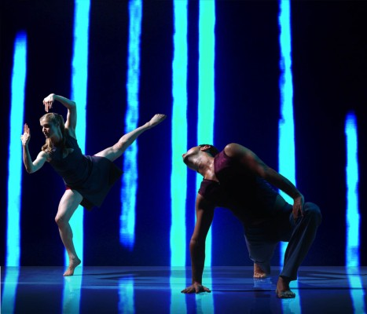

Exit No Exit, 2006. Photo: Chris Nash. Dancer: Kamala Devam, Mandeep Raikhy

<http://www.shobanajeyasingh.co.uk/gallery/images/>

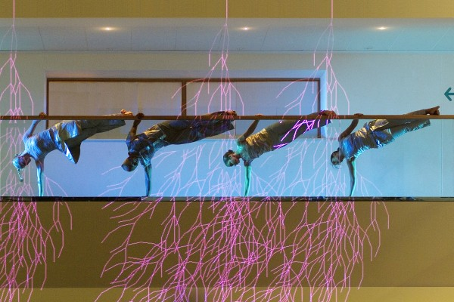

Foliage Chorus, 2004. Photo: Vipul Sangoi. Dancers: Kamala Devam, Saju Hari, Navala Chaudhari, Rathimalar Govindarajoo

<http://www.shobanajeyasingh.co.uk/gallery/images/>

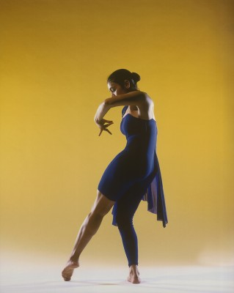

Phantasmaton, 2002. Photo: Chris Nash. Dancer: Sowmya Gopalan

http://www.shobanajeyasingh.co.uk/gallery/images/

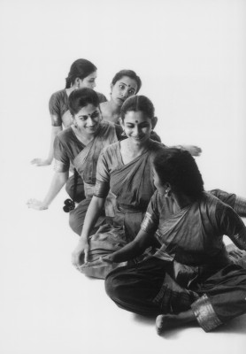

Making of Maps, 1992. Photo: Hugo Glendinning. Dancers: Subathra Shanteepan, Vidya Thirunarayan, Monisha Patil, Savitha Shekhar, Verni Jaganathan

<http://www.shobanajeyasingh.co.uk/gallery/images/>

Copyright: Please direct queries regarding copyright to:

Martha Oakes PR  
113 Heathwood Gardens  
London SE7 8ET  
+44 20 8854 5460  
+44 7798 626555

martha@marthaoakespr.co.uk

1. Personal correspondence, Janet O’Shea and Shobana Jeyasingh, August 1999.